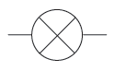 | BULB (LAMP)  A component which lights up when electricity passes through it in a circuit | 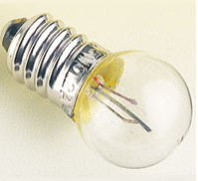
 | MOTOR  A component which moves (spins) when electricity passes through it in a circuit | 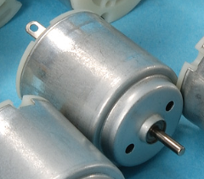
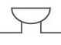 | BUZZER  A component which makes a sound when electricity passes through it in a circuit | 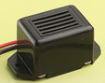
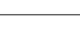 | WIRE  Plastic-coated electrical wire which conducts electricity around a circuit | 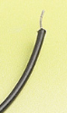
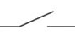 | SWITCH  Part of a circuit which can easily be opened or closed to control the flow of electric current | 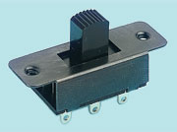
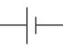 | CELL – 1 battery  A safe power source. A store of chemical potential energy that can power a circuit | 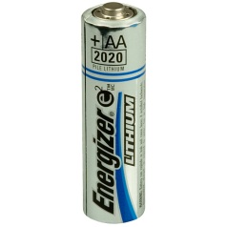
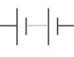 | CELL – 2 batteries  Two cells used together to make a more powerful power source | 

