
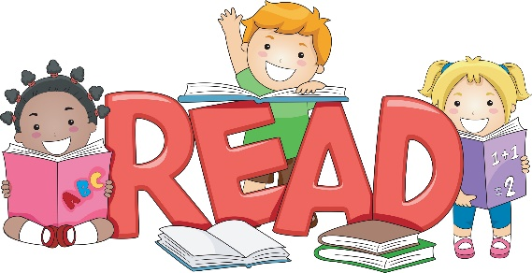
Adjectives

Adjectives are used to describe a noun.
Describe your nouns using expanded noun phrases.
Read your work and include more adjectives.
Use classroom resources to help up-level your work.

Proof

Read your work out loud to yourself.
Does it all make sense?

You might want to re write a sentence in green pen.

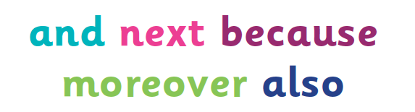
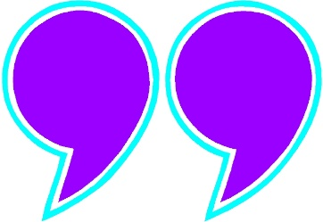
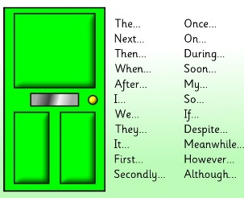
Connectives

Connectives are used to join clauses or ‘ideas’ together.
Read your work to check how many connectives you have. If you don’t have many include some more!
Use the classroom resources to help you.

and, because, next, moreover, also, so, then, however, as well as, but, furthermore, later
Inverted Commas

Inverted commas are used to punctuate speech and quotes. They should be used at the beginning and send of the speech.
“I warn you, here is something wrong” stated Mr Simmons.
Check you have speech marks in the correct places.
Fronted Adverbials

Fronted Adverbials are used at the start of a sentence. They can be used to show time, manner or place. They also have a comma after them.
Read your work and check you have included a range of Fronted Adverbials.
In the morning, Soon after, Anxiously, As fast as lightening, At the park, As the sunset, In the wooden house

Capital letters and full stops
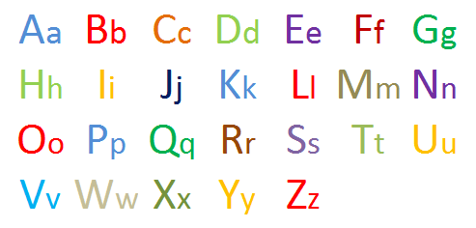
A capital letter is at the start of every sentence. Also used for a name, place and the pronoun ‘I’.
The cat called Sue chased the mouse.
Full stops are at the end of every sentence.
The cat called Sue chased the mouse.
Spelling
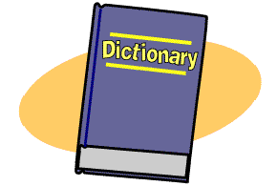
Use the Y3 and Y4 word list to help you.
Check your spellings in the dictionary.
Add your mistakes to your own dictionary.

