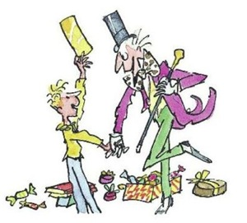
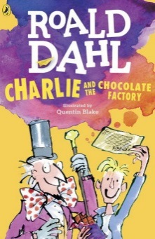


Extract from Charlie and the Chocolate Factory, by Roald Dahl

oh what a man he is this mr willy wonka cried grandpa joe
Did you know, for example, that he has himself invented more than two hundrd new kinds of chocolate bars each with a different centre each far sweeter and creamier and more delisious than anything the other chocolate factorys can make

mr willy wonka can make marshmallows that taste of violets and rich caramels that cange culor every tow seconds as you suck them and litle feathery sweets that melt away the moment you put them beween your lips he can also make chewing gum that never loses its taste and sugar ballowns that you can blow up to enormous sizes before you pop them with a pin and gobble them up. grandpa joe took a deap breth his mouth was watering at the thort.

