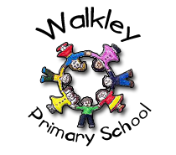 | Walkley Primary School – Y2 Learning Log Gruffalos
Topic:  ‘’ Land Ahoy!” |  |  |  |  |  | Here are some examples of the children’s work carried out in Summer 1.
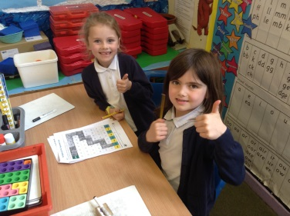 |  |  | 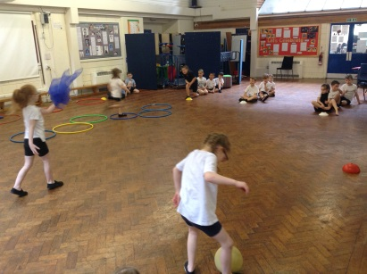 |  |  |  |  | 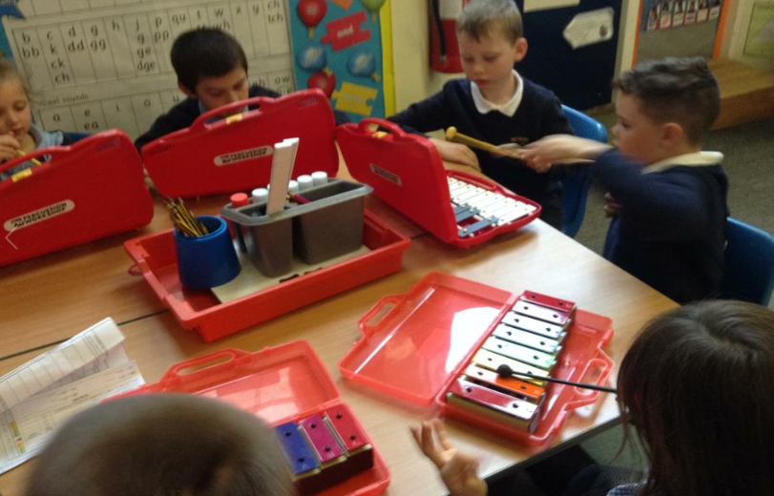
Learning Log Summer 1 – Topic: Land Ahoy!
To continue our theme: “Land Ahoy!’ we are continuing our approach to homework that will give your child the opportunity to demonstrate their knowledge and ‘creative flair’.  - Children choose their own method to present their learning.  - The tasks will be open ended.  - There is no one right way of presenting the work. |  |  |  |  | It would be GOOD if you could complete 4 out of the 9 activities.  It would be GREAT if you could use ICT in your work.  It would be AMAZING if you could complete a range of activities (write, research, make, discuss, draw).
Research: About Australia, Easter Island or the Maldives |  |  | Make: A lunch box for Takashi san, our Japanese Lighthouse keeper! |  |  |  |  | Research and watch: Blue Planet 2 on iplayer and try these quizzes! (https://www.bbc.co.uk/cbbc/quizzes/blue-planet-one-ocean)
Draw:  Your own island map! What natural and man-made geographical landmarks would it have? Which ocean would it be in? |  |  | Sing: The plastic bag song by Nick Cope  https://www.youtube.com/watch?v=UZQ0L3bolFw |  |  |  |  | Write and draw: A list of things you will need to travel around the world investigating different oceans and islands. E.g. First Aid kit, scuba gear etc
Research: The incredible Greta Thunberg. (You could start by looking on our blog!) |  |  | Design and Make: A submarine to see the incredible creatures found in the depths of the oceans! |  |  |  |  | Help recycle plastics at home: Help your adults put out the blue bins or take plastics to recycling skips.
 |  |  |  |  |  |  | Parent/Carer Comments
  Every week in term time I must also: | What I think  of my work in Summer 1 | What my teacher thinks
  Remember to: | What I think  of my work in Summer 1 | What my teacher thinks
  - Read my reading books.
  - Complete my Spelling Point Contract.
  - Practise my Learn Its.
  - Talk to my grown-ups about what I’m learning in school.

