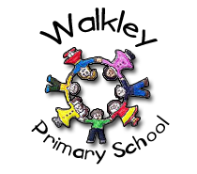 | Walkley Primary School – Y2 Learning Log Gruffalos
Topic:  ‘People who have positively changed the world!’ |  |  |  |  |  | Here are some examples of the children’s work carried out in Spring 2.
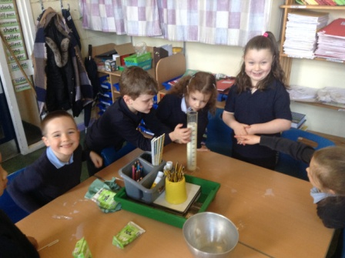 |  |  | 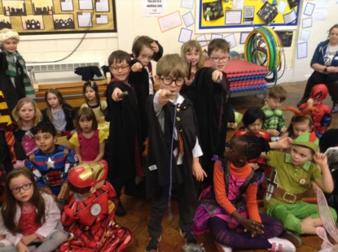 |  |  |  |  | 
Learning Log Spring 2 – Topic: Land A hoy!
To continue our theme: “People Who Have Positively Changed The World!’ we are continuing our approach to homework that will give your child the opportunity to demonstrate their knowledge and ‘creative flair’.  - Children choose their own method to present their learning.  - The tasks will be open ended.  - There is no one right way of presenting the work. |  |  |  |  | It would be GOOD if you could complete 4 out of the 9 activities.  It would be GREAT if you could use ICT in your work.  It would be AMAZING if you could complete a range of activities (write, research, make, discuss, draw).
Research: About an island country other than Britain e.g Iceland, Japan, The Maldives, Cuba |  |  | Make: a passport for you to travel with! |  |  |  |  | Design: A research ship for ten people to take them around the world’s oceans.
Draw:  The outline of a real island in the world by using a map, globe or atlas |  |  | Read: A story based on island. E.g. Katie Morag adventures, Kensuke’s kingdom, Moana, Treasure island or the Lighthouse keepers lunch |  |  |  |  | Write: A story about being stuck on a deserted island. How did you get there? What objects did you have with you? What did the island look like (make a map) How did you eat? What shelter did you make? Were you rescued in the end?
Research: About an island you would like to travel to. |  |  | Design and Make: something recycled from plastic bottles |  |  |  |  | Make a fact poster: About how we need to recycle plastics more as our oceans are becoming so polluted
 |  |  |  |  |  |  | Parent/Carer Comments
  Every week in term time I must also: | What I think  of my work in Summer 1 | What my teacher thinks
  Remember to: | What I think  of my work in Summer 1 | What my teacher thinks
  - Read my reading books.
  - Complete my Spelling Point Contract.
  - Practise my Learn Its.
  - Talk to my grown-ups about what I’m learning in school.

