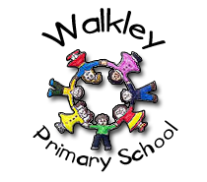 | Walkley Primary School – Y2 Learning Log Gruffalos
Topic:  ‘People who have positively changed the world!’ |  |  |  |  |  | Here are some examples of the children’s work carried out in Spring 1.
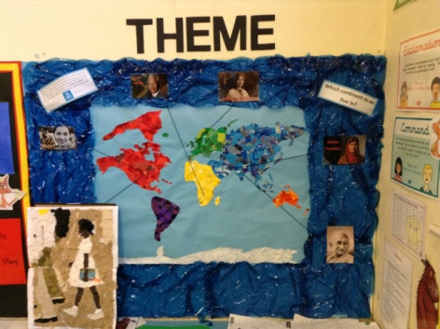 |  |  | 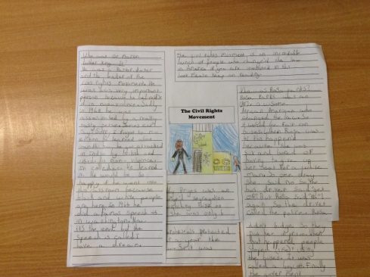 |  |  |  |  | 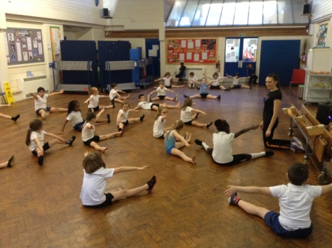
Learning Log Spring 2 – Topic: People Who Have Positively Changed The World!
To continue our theme: “People Who Have Positively Changed The World!’ we are continuing our approach to homework that will give your child the opportunity to demonstrate their knowledge and ‘creative flair’.  - Children choose their own method to present their learning.  - The tasks will be open ended.  - There is no one right way of presenting the work. |  |  |  |  | It would be GOOD if you could complete 4 out of the 9 activities.  It would be GREAT if you could use ICT in your work.  It would be AMAZING if you could complete a range of activities (write, research, make, discuss, draw).
Research: About Gandhi and his amazing work using non-violence |  |  | Make: a collage of an inspiring person |  |  |  |  | Design: A protest sign for suffragettes
Draw:  The UN flag |  |  | Try: To relax and be at peace, please try Tai Chi  https://www.youtube.com/watch?v=alCP5R3EFxA |  |  |  |  | Write: About a person who inspires you. It could be a family member, sports hero or historical figure.
Research: About a country you would like to travel to. |  |  | Design and Make: A model plane so you can imagine travelling to different continents |  |  |  |  | Make a fact poster: About one of the people you have learnt about last term
 |  |  |  |  |  |  | Parent/Carer Comments
  Every week in term time I must also: | What I think  of my work in Summer 1 | What my teacher thinks
  Remember to: | What I think  of my work in Summer 1 | What my teacher thinks
  - Read my reading books.
  - Complete my Spelling Point Contract.
  - Practise my Learn Its.
  - Talk to my grown-ups about what I’m learning in school.

