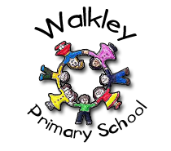 | Walkley Primary School – Y2 Learning Log Gruffalos
Last Term’s Topic:  ‘The Gruffalo Show!’ |  |  |  |  |  | Here are some examples of the children’s work carried out in Autumn 1.
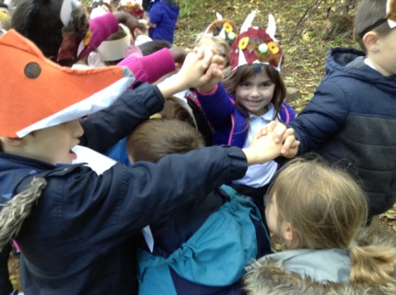 |  |  | 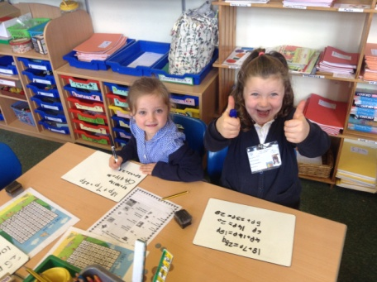 |  |  |  |  | 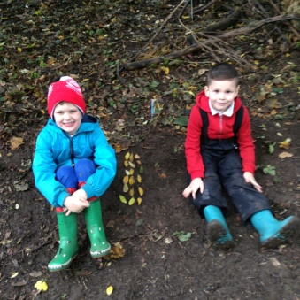
Learning Log Autumn 2 – Topic: People Who Have Positively Changed The World!
In preparation for next term’s topic “People Who Have Positively Changed The World!’ we are continuing our exciting new approach to homework that will give your child the opportunity to demonstrate their knowledge and ‘creative flair’.  - Children choose their own method to present their learning.  - The tasks will be open ended.  - There is no one right way of presenting the work. |  |  |  |  | It would be GOOD if you could complete 4 out of the 9 activities.  It would be GREAT if you could use ICT in your work.  It would be AMAZING if you could complete a range of activities (write, research, make, discuss, draw).
Research: About the United Nations.  What is it?  Where is its head quarters |  |  | Make: a collage using leaves or paper. It can be about anything you like! |  |  |  |  | Design: A flag to represent the world
Draw:  A map of the world and label its continents. |  |  | Try: To relax and be at peace, please try  https://www.youtube.com/user/CosmicKidsYoga |  |  |  |  | Write: About what you would do to change the world.
Research: Who Ruby Bridges is and what was the brave thing she did as a little girl |  |  | Design and Make: A board game where you travel the world doing good deeds. |  |  |  |  | Make a fact poster: About a person you admire. It could be someone famous or someone you know
 |  |  |  |  |  |  | Parent/Carer Comments
  Every week in term time I must also: | What I think  of my work in Summer 1 | What my teacher thinks
  Remember to: | What I think  of my work in Summer 1 | What my teacher thinks
  - Read my reading books.
  - Complete my Spelling Point Contract.
  - Practise my Learn Its.
  - Talk to my grown-ups about what I’m learning in school.

