Maths Homework summer 1 week 3
Money!
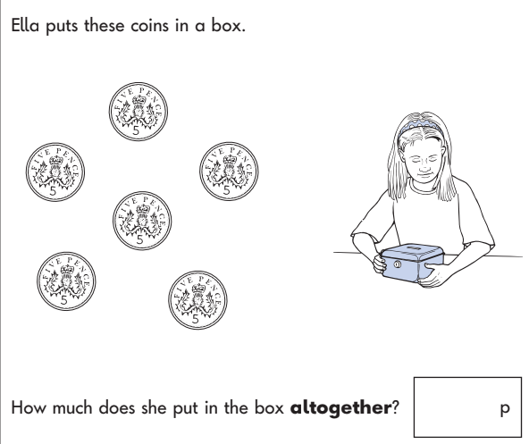
Time!
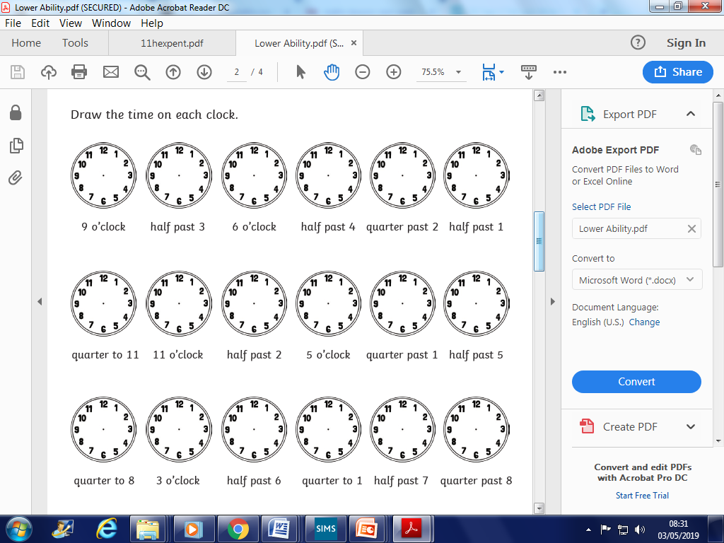

shape!
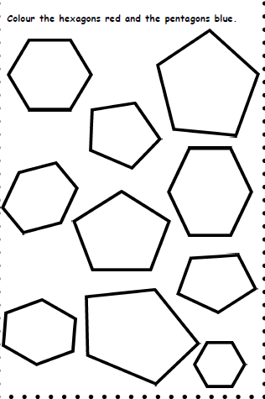
If you can, please go on this website and challenge your 2 and 5 times table knowledge with these games!
https://www.timestables.co.uk/happy-burger.html
2 x 7 = 2x9= 5 x 5 =

