Maths Homework summer 1 week 2
Time!
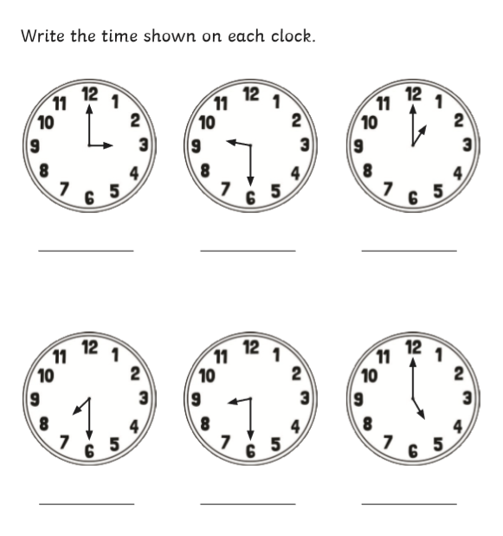

Fractions of shape!
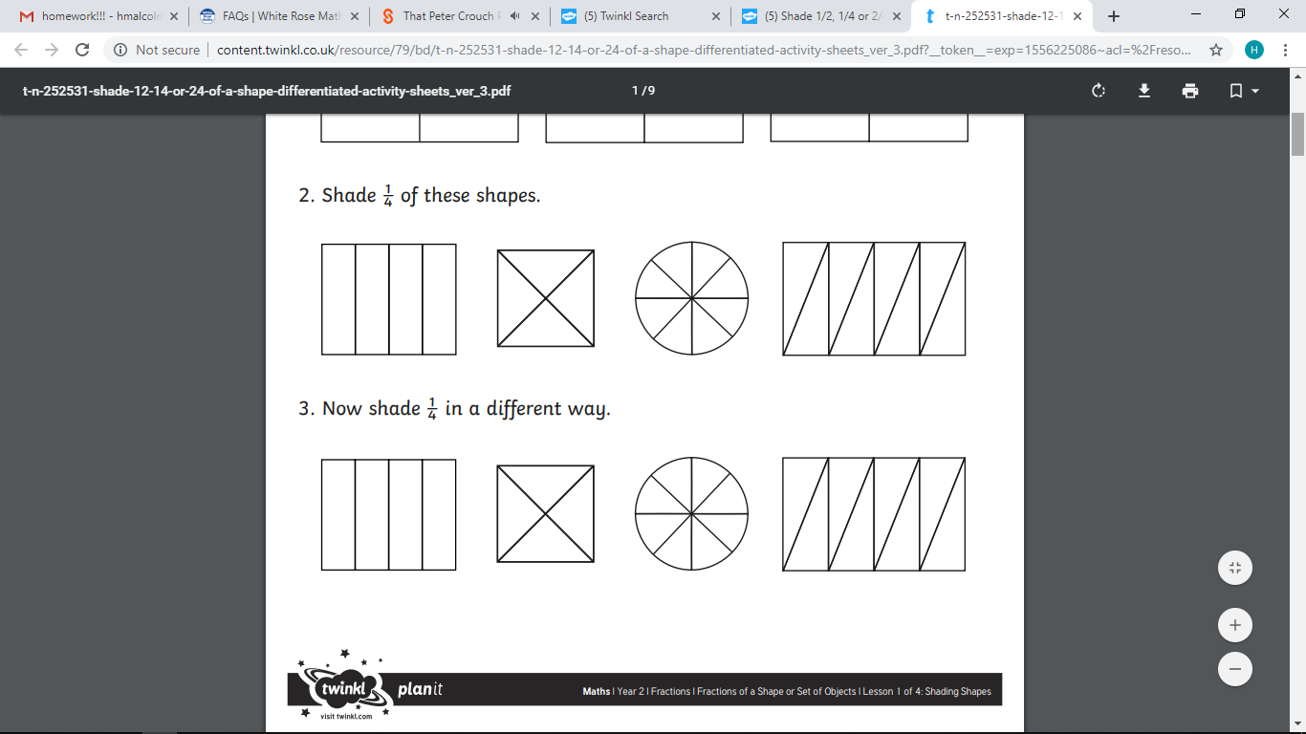
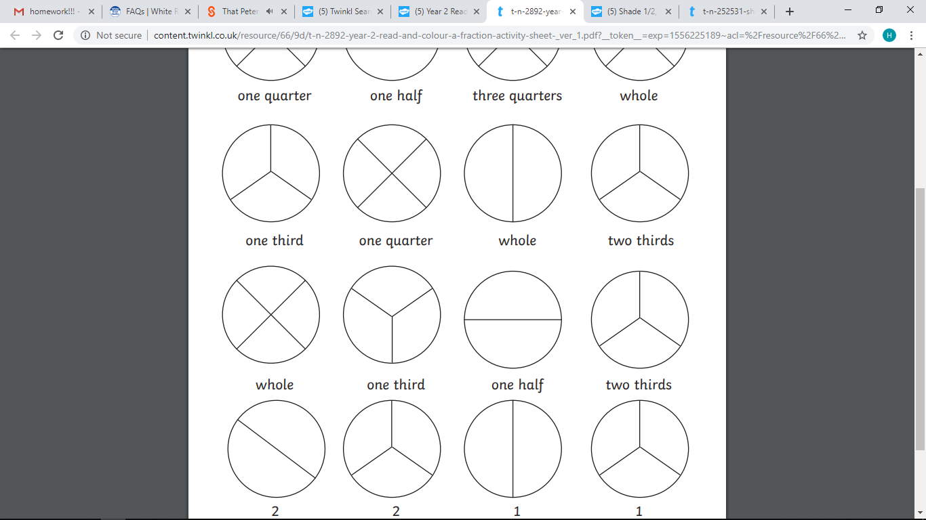
If you can, please go on this website and challenge your 2 and 5 times table knowledge with these games!
https://www.timestables.co.uk/happy-burger.html
2 x 4 = 2x10= 5 x 3 =

