Maths Homework summer 1 week 1
Fractions of number! (remember to find a ¼, ½ and ½ again!)
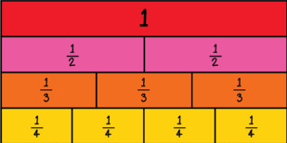
½ of 8=
1/4 of 8 =
¾ of of 8= (3 x ¼)
½ of £20 =
¼ of £20=
¾ of £20 =
½ of £400 =
¼ of £400 =

Reasoning questions
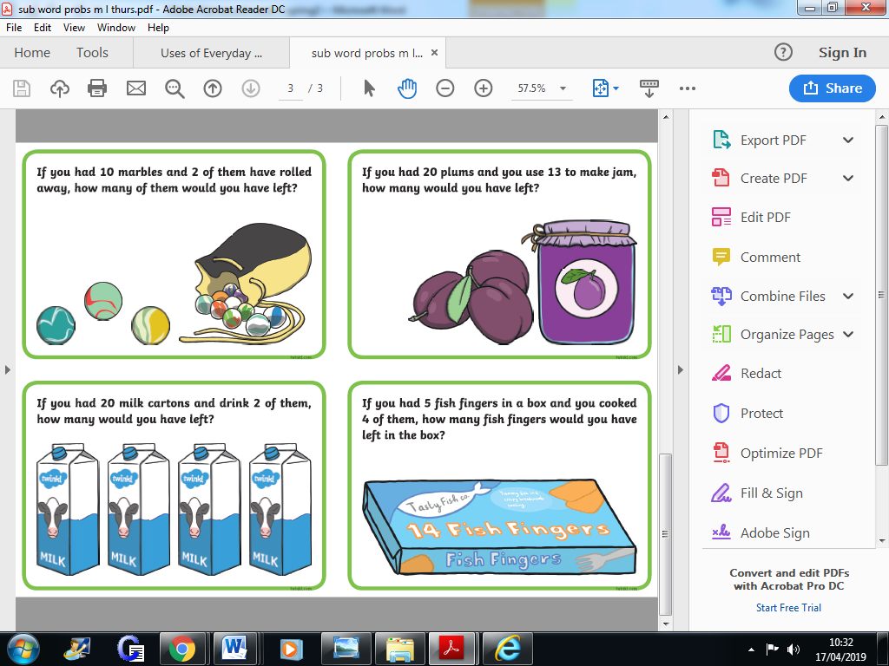
If you can, please go on this website and challenge your 2 and 5 times table knowledge with these games!
https://www.timestables.co.uk/speed-test/

