Maths Homework Spring 2 week 1
Fractions of number! (remember to find a ¼, ½ and ½ again!)

½ of 4=
½ of 6=
½ of 8=
¼ of 8=
¾ of 8 =
½ of 20=
¼ of 20 =
½ of 40 =
¼ of 40 =

Time!
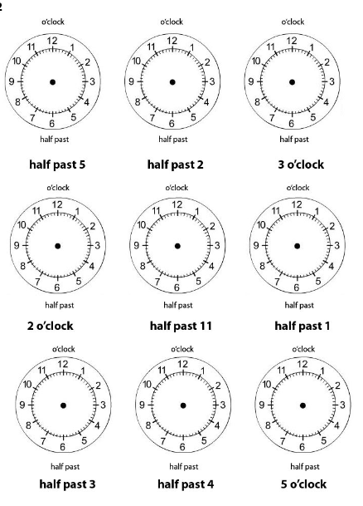

If you can, please go on this website and challenge your 2 and 5 times table knowledge with these games!
https://www.timestables.co.uk/speed-test/

