Maths Homework Spring 2 week 1
Time!!
Please draw the minute and hour hand to tell the correct time:

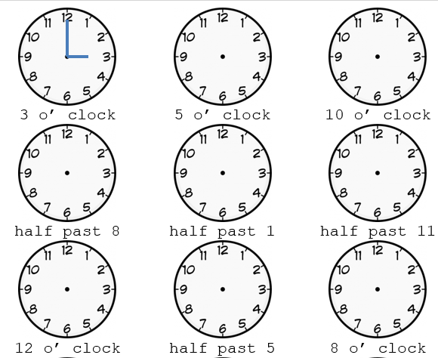

Problems

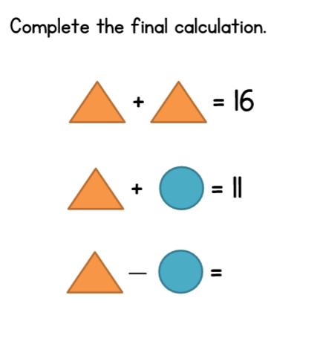

If you can, please go on this website and challenge your 2 and 5 times table knowledge with these games!
https://www.timestables.co.uk/speed-test/

