Maths Homework spring 1 week 3
A 2 step problem
+ -
You will need to use two steps to solve this problem. Do you subtract and then add or add and subtract?!
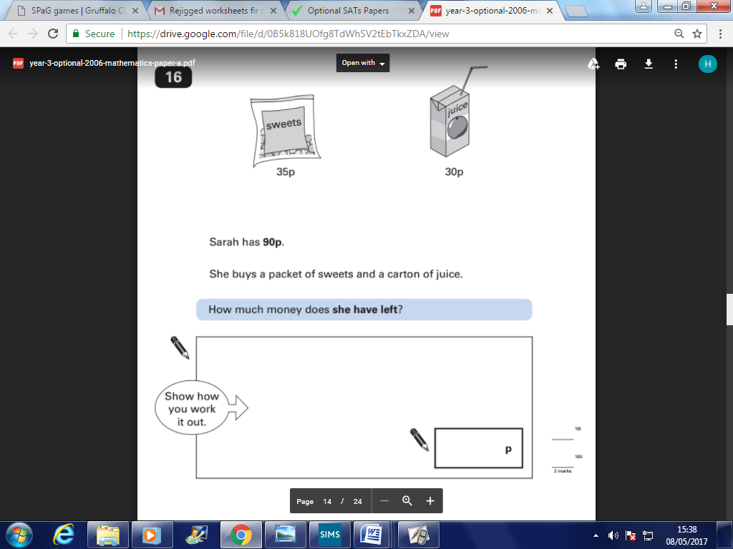
Word Problems
Please read carefully to work out what you need to do


