Maths Homework Autumn 1 week 7
Subtraction Step 18:
Remember to:
- Find the starting number
- Count back 10
- See where you’ve landed
24 – 10 = 11 – 10 =
33 – 10 = 45 – 10 =
22 – 10 = 40 – 10 =
34 – 10 = 67 – 10 =
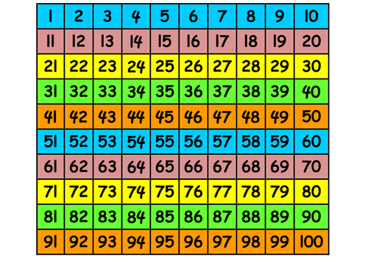

Multiply by 2:
2 X 4 = 5 X 2 = 2 X 8 =
Double 5 = Double 8 =
2 lots of 10 = 2 lots of 3 =
5 groups of 2 = 2 groups of 2 =
2 X 12 = 2 X 15 = 2 X 50 =
Sam has 10 cars, Sally has twice as many. How many cars does Sally have?
____________________________________


