Numeracy
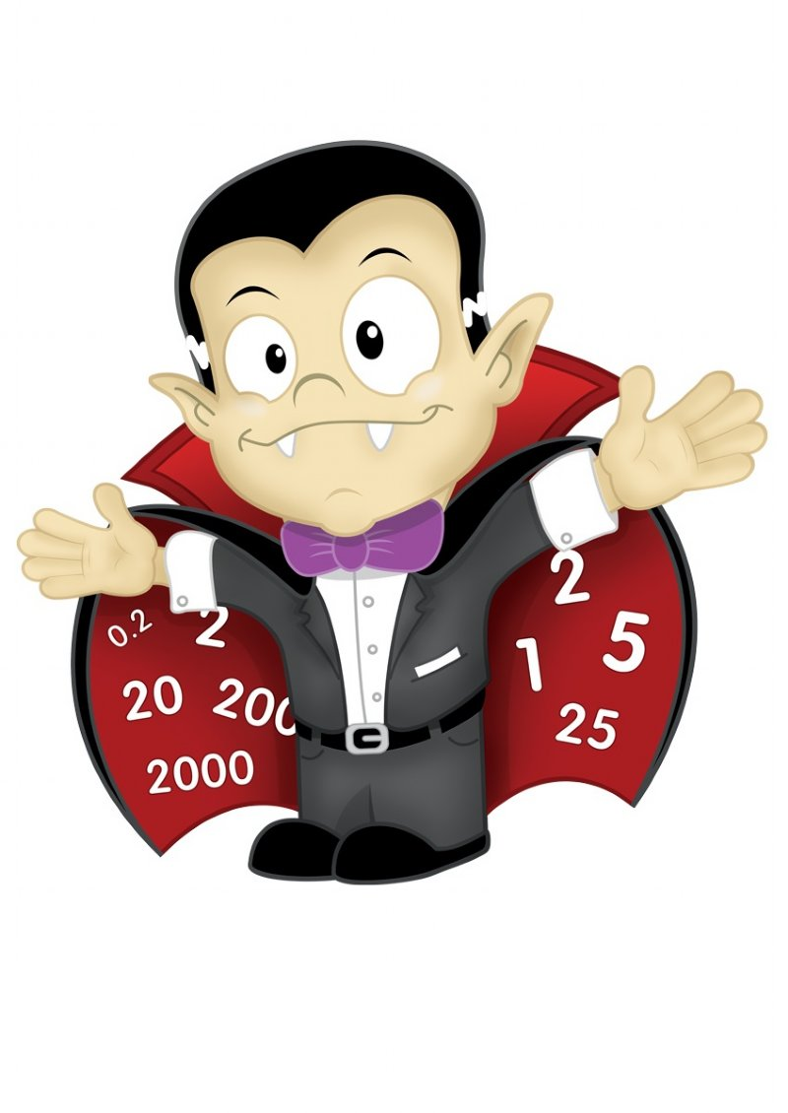
In preparation for the maths SAT examinations, children will be revising key place value and number skills with our newly acquired maths manipulatives (See below). In addition, we will continue to learn to use our new “bar” method to help us solve addition, subtraction, division and multiplication word problems.
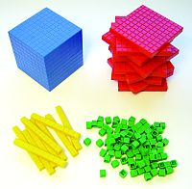
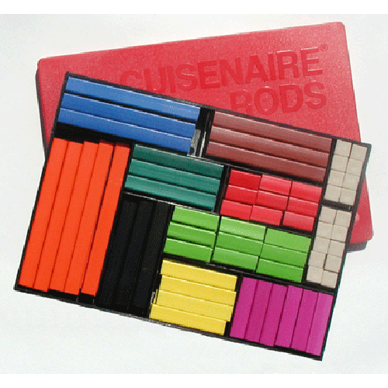
Science
Science and our topic will be:
Use of everyday materials
We will look at various materials and do experiments about their strength, durability and flexibility.
From this, we will build the ultimate Japanese lighthouse keeeper’s lunch box carrying basket which will withstand harsh winds, rain and pesky seagulls.

Read Write Inc
Read Write Inc continues! Children are either in small, focused RWI groups or in a Star writing group.

This term the Y2 star groups will be writing persuasive holiday brochures, informative texts on our environment, ship captain’s logs and an article for National Geographic kids on our imagined island hopping travels around the globe!

How You Can Help
Please ensure that you are punctual for school, arriving by 8.45 before doors are locked at 8.50. If you arrive later please remember to sign in at the office.
If your child is off school ill, please ring school to let us know straight away.
Spellings will be sent out each Friday and tested on a Thursday
We will send Big Math’s Learn It sheets home every Friday!
Please read with your child and leave a comment in their reading records.
Remember that PE is on Friday so please ensure they have a PE kit in school.
Don’t forget school meals are FREE for Foundation, Y1 and Y2. Milk is payable in the school office!

Physical Education: This term the Gruffalos will be focusing on throwing and catching skills this term. This will involve balloons, bean bag targets, ten pin bowling and lots more to test the hand eye co-ordination and balance!
visit our Class Blog at:
http://www.walkley.sheffield.sch.uk/
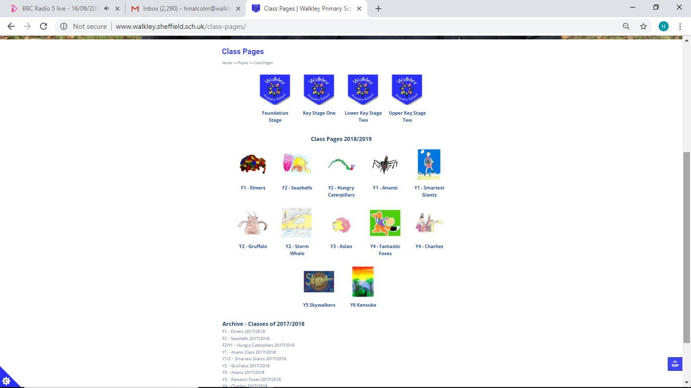
Creative Curriculum
Our topic is Land A Hoy! The Gruffalos have been tasked with exploring the seas to write a large feature article for National Geographic kids magazine. The editor, Susan Goldberg, has asked us to include descriptions of the culture and life of a variety of islands around the world. Additionally, a sub feature is required on climate change and the effect of pollution.

Year 2
Spring 2
Topic: Land A Hoy!
Teachers: H. Malcolm
TA: A. Wieczorek



