Week 3
This week’s sounds are:
c k u b f
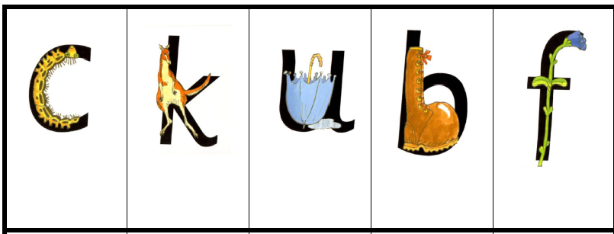

Week 3
This week’s sounds are:
c k u b f

