Week 4
This week’s sounds are:
e l h sh r
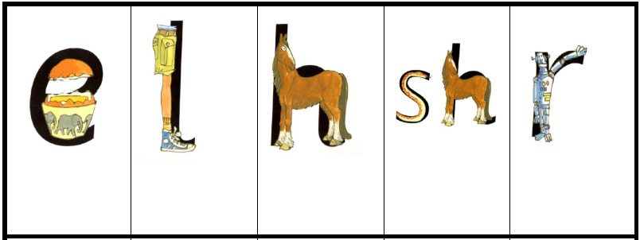

Week 4
This week’s sounds are:
e l h sh r

