Week 5
This week’s sounds are:
j v y w th
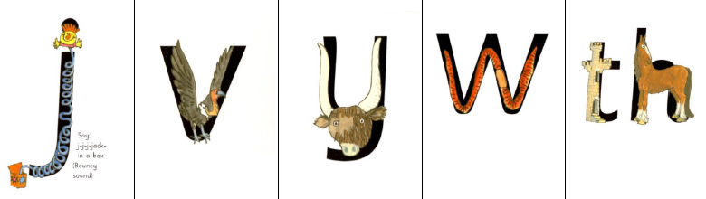

Week 5
This week’s sounds are:
j v y w th

