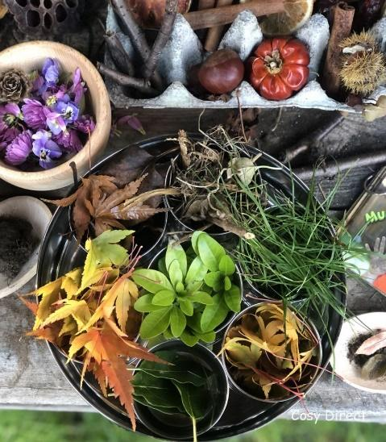
Occupational Therapy Student Project

What is Occupational Therapy?
“Occupational therapy enables people to participate in daily life to improve their health and wellbeing. Daily life is made up of many activities (or occupations). Occupations for children or young people may include self-care (getting ready, eating a meal, using the toilet), being productive (going to nursery or school), and leisure (playing/interacting with friends or doing hobbies)” – College of Occupational Therapists

Who are we and why are we at Walkley primary school?
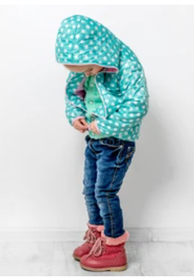
Our names are Beth and Amy, and we are currently completing our master’s degree in occupational therapy at Sheffield Hallam University. Throughout our course we have to complete four placements at different settings - Walkley primary school is our third placement. During this placement we are expected to go into a service where there is no Occupational Therapist working, such as Walkley Primary School. We then have to get to know the service and develop a project to help an area of occupational need. To do this we have spent two weeks observing different lessons and have identified two areas of occupational need in the nursery, where we hope we can use our projects to help your child develop. The two projects have been endorsed and developed with Mrs English (Nursery class teacher) and Mrs Homer (Designated Safeguarding Lead and Inclusion Manager).

Mud Kitchen Project
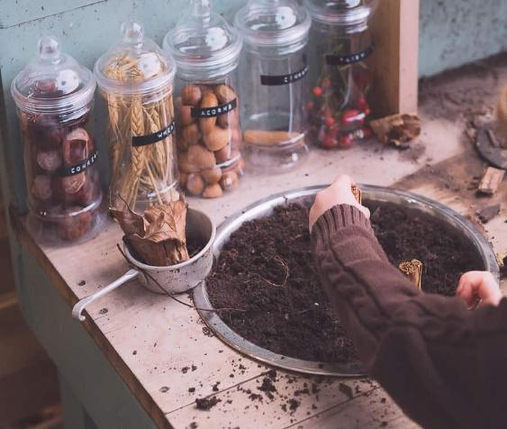
I (Beth) have decided to run a mud kitchen project for the next 4 weeks focusing on social interaction such as, initiating conversation with peers, sharing and turn taking. This will run as part of the children’s usual free-flow play time.

A mud kitchen encourages children to talk about what they are doing as well as role play, sharing and turn taking. Often the excitement of being outside and the involvement in messy play gives young children the confidence to talk about their thoughts and feelings. Children are able to explore the outdoor environment and are amazing spaces to spark children’s imagination. Occupational Therapists are keen to keep the focus on meaningful functional tasks therefore I aim to create some basic recipe cards for the children to follow with the support of myself and Amy.

When working in a mud kitchen, children practise using utensils, measuring and pouring mud, and mixing up items. These techniques help children to develop and practise their fine motor skills. It will be made clear to the children that the mud kitchen is for role play purposes with a no eating sign made clearly visible. The children will be supervised throughout the sessions.

Utilising the Montessori theory which allows children to learn at a pace that is congruent to their development. Occupational Therapists use different models to aim to enable children to participate and engage in activities of daily living.

I am to run the mud kitchen sessions twice a week for the next 4 weeks. This will give me time to evaluate each session and see what worked well or what could be improved for the next session. I look forward to working with your child and hope that some of these skills will be helpful at home.

Dressing Frame Project
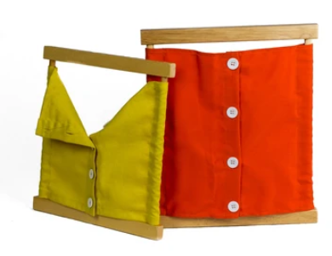
I (Amy) have decided to focus on developing the children’s ability to do up fastenings, such as buttons and zips, to promote their ability to dress themselves independently. This project has been developed in agreement with and alongside Mrs English and Mrs Homer, as it has been flagged up that many of the children struggle to dress themselves due to difficulty doing up fastenings such as zips on coats.
I will use the style of Montessori dressing frames, as pictured, to provide an opportunity to practise these skills. They may also practise doing zips on their coats, but they will not be changing their clothes or dressing in the nursery. The dressing frames will provide the children with varying difficulty levels, e.g., three big buttons to 5 small buttons, allowing them to progress their skills. I look forward to helping the children develop their skills and reach the developmental milestone of being able to dress themselves independently. When they are 4 years old, children are expected to be able to independently dress themselves, apart from more difficult fastenings such as laces and fastenings behind their backs.
Practice doing up these clothes fastenings will also improve the children’s fine motor skills, which will hopefully lead to them having better abilities to do other tasks that require fine motor skills, such as holding pens and pencils.
The dressing frames will be offered as part of the children’s free-flow playtime. Beth and I will be helping the children engage with the dressing frames to ensure they are engaging with the tasks appropriately. Hopefully, this will be helpful for your child and support your teaching of dressing skills at home.

If you have any questions or would like to know more about our projects, please contact the school’s pastoral team or email enquiries@walkley.sheffield.sch.uk for the attention of Mrs English

