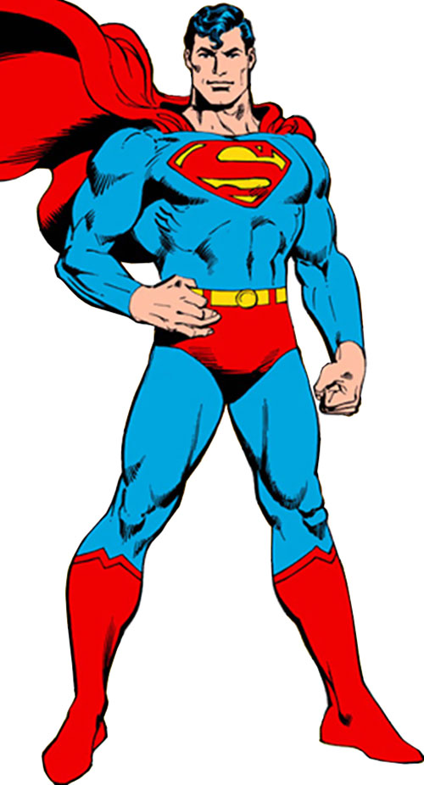

This superhero’s name is Superman. He is called the man of steel. He is from outer space and came to planet Earth as a baby.
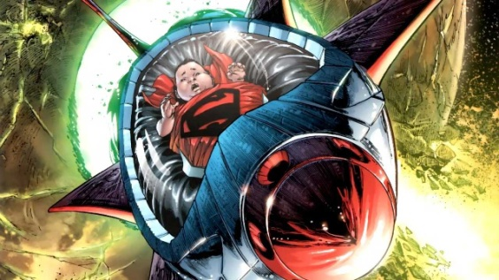
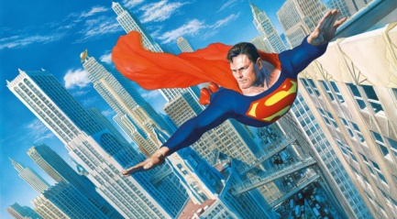
What superpowers does he have?
He can see through walls, fly and is very fast.
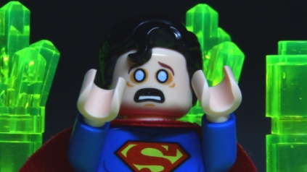
What is his weakness?
A green rock called Kryptonite makes him sick.

What is Superman’s secret identity?
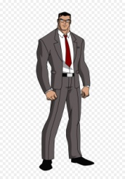
Superman hides his identity by wearing glasses and calling himself Clark Kent.

