Gruffalo Maths Homework Autumn2 Week 2
Subtraction
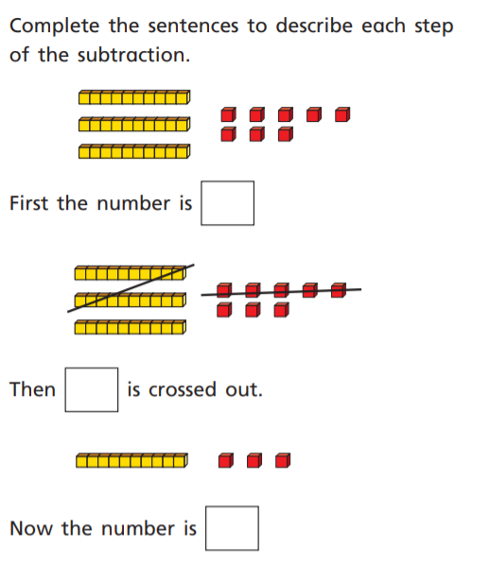
Please draw your working out!
24 – 12=
Times table Rock Stars!!
2 x 2 =
2 x 5 =
2 x 3 =
2 x 10 =
2 x 1 =
2 x 6 =
5 x 2 =
3 x 2 =

Please have a go on a tablet, mobile or computer this weekend!!!

