Reading timer
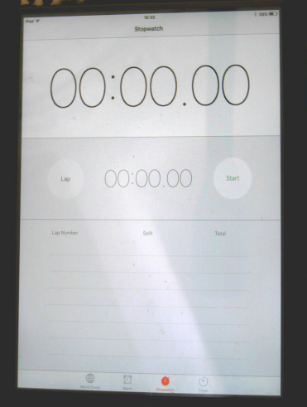
fow row tow blow stow grow pow trow low quow drow jowt phowb mowl zowp bowd below snow flown crow own show phowt vowd bow shadow sow powgeet flow

