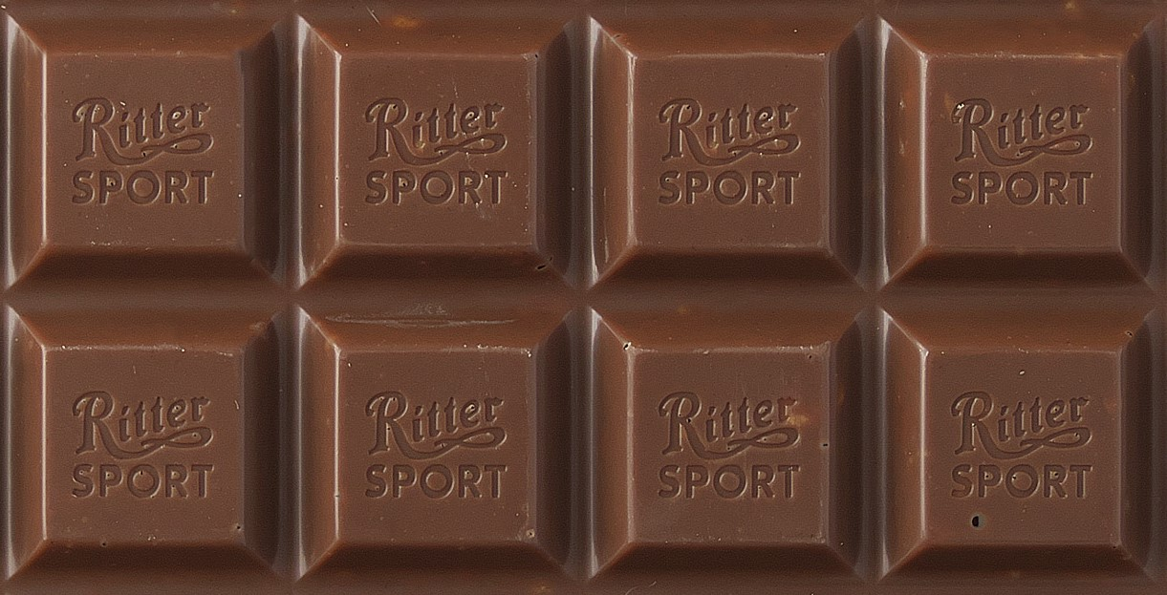
This lovely-looking chocolate bar is divided into 8 equal parts. Each of those equal parts is $\frac{1}{8}$ . Two of those pieces are the same as $\frac{1}{4}$ ; four are the same as $\frac{1}{2}$ . If you’re a chocolate-lover, which of these fractions would you rather have? Would you prefer to have $\frac{5}{8}$ or $\frac{1}{2}$ ? Why?

$$\frac{1}{2}$$

$$\frac{1}{4}$$
$$\frac{1}{8}$$
If you really don’t like chocolate, which piece would you have? Why?

