L.O. Add fractions within 1, different denominators. Square Hexagon  Remember to: | What I think | What my teacher thinks
Use a bar model to compare fractions.
Find a common denominator.
Add the numerators.
Simplify the resulting fraction.
Do me first:

48 ÷ 6 =

42 ÷ 7 =

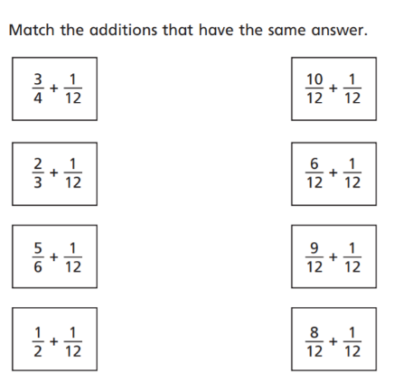

L.O. Add fractions within 1, different denominators.  Pentagon Quadrilateral  Remember to: | What I think | What my teacher thinks
Use a bar model to compare fractions.
Find a common denominator.
Add the numerators.
Simplify the resulting fraction.
Do me first:

480 ÷ 6 =

420 ÷ 7 =

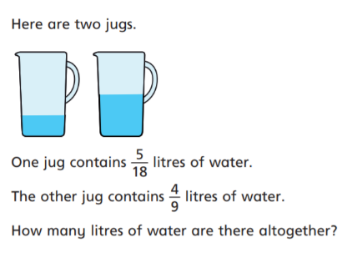

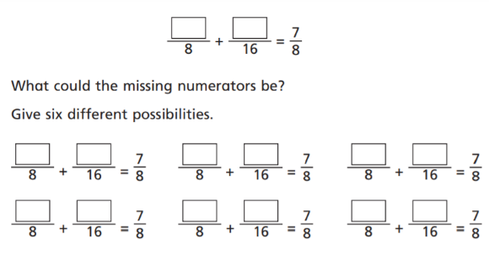

#

L.O. Add fractions within 1, different denominators. Triangle  Remember to: | What I think | What my teacher thinks
Use a bar model to compare fractions.
Find a common denominator.
Add the numerators.
Simplify the resulting fraction.
Do me first:

480 ÷ 12 =

420 ÷ 14 =



